**2021.11.18 Diffraction Experiment**

**Start Time:** circa 09.00

**Aim**

An experiment was carried out to compare the results from diffraction patterns when a laser illuminates various narrow slits, and comparing them with the predictions that we obtain from the wave theory of light. These diffraction patterns were captured by a CMOS camera, and processed using ImageJ and Python (Numpy, Matplotlib, Scipy).

**Background**

Multiple waves may be superimposed, such that the resultant amplitude, hence intensity, depends upon the characteristics of the component waves - this is called interference, or diffraction, depending upon the experiment’s geometry. When speaking in terms of a few waves *(such as those originating from different optical paths)* we opt for *interference*, whilst when describing a continuum of waves *(such as light passing through a single slit)* we opt for *diffraction* to describe the situation.

Diffraction that occurs close to an object, known as *near-field diffraction*, can become rather mathematically challenging, hence a simpler scenario known as *far-field diffraction* was employed instead, where the object is assumed to be very far from the aperture (ideally at ∞, shown in Fig. 1a). As this isn’t achievable in a lab setting, an equivalent effect is accomplished through the use of a converging lens (as shown in Fig. 1.1b), where rays diffracted at an angle θ are observed at distance *x* from the principal axis of the lens, where for small angles (in rad), θ = x/f.

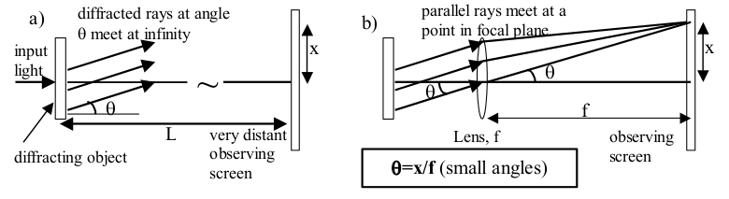

Figure 1: laser beam is diffracted. in a), far-field diffraction pattern is obtained from a very distant detector, whilst at b), they meet in the focal plane of a lens.

Source: Mangles et. al, 2021, “Year 1 Laboratory Manual: Diffraction Experiment”, Imperial College

**Single Slit Diffraction**

For a *far-field diffraction* pattern of a single slit, the intensity of light is found by summing the amplitudes of the electric field from each elementary point on the slit, following from the Huygens’ Principle. Then, by squaring the amplitude pattern, the intensity I(x) is obtained for a given slit of width a, as a function of distance in the observation plane from the central maximum (x).

whereby I0 gives the intensity at the centre, and λ is the wavelength of light. This equation relies on the use of the small angle approximation, which gives that θ ≈ x/f. Additionally, a, x, λ and f all have dimensions of length, therefore must be expressed in identical units (i.e. millimetres has been chosen through this practical).

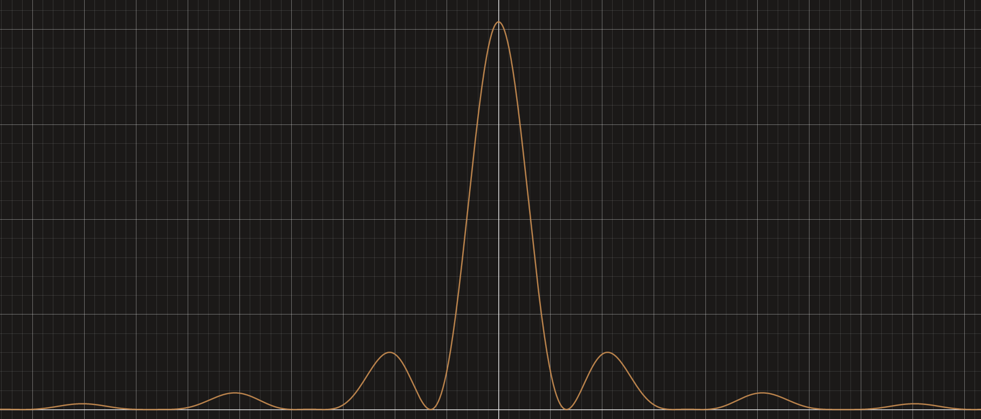

Figure 2: The following graph below shows the single slit diffraction pattern, given in (1.1)

Source: Desmos, Graphing Calculator

Solving 1.1, we find the zeros of intensity in a single slit diffraction pattern occur at the x-coordinates *xm* given by the following, where m represents minima number, such as m = ±1, ±2, ±3, etc.

Which rearranges to give us the following equation:

Thus, the spacing of the minima in this diffraction pattern can be used to attain a.

**Double Slit Interference**

Geometry is used to derive the interference pattern that results from light passing through two idealised (infinitely narrow) slits. Given this, then we have that the difference between the two paths (S1P and S2P) from a distant detector is given by:

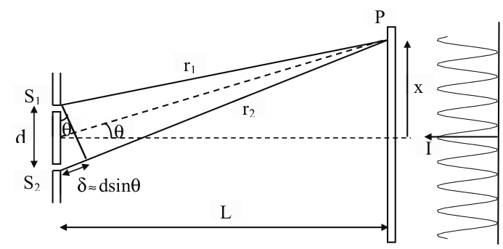

Figure 3: geometry for double-slit interference. L >> 0, δ ≈ d·sin(θ)

Source: Mangles et. al, 2021, “Year 1 Laboratory Manual: Diffraction Experiment”, Imperial College

Total light amplitude at any given point P on the observation axis is attained as the vector sum of amplitudes originating from both slits, taking into account their phase difference. Thus the positions of total constructive and destructive interference are given by: MAXIMA at *d · sin(θ) = mλ*, and MINIMA at *d · sin(θ) = (m+½)λ* respectively, where m = ±1, ±2, ±3, etc.

Yet, since observations will be taken from the focal plane of a lens, we can substitute in our approximation from Fig. 1(b), that sin(θ) ≈ θ ≈ x/f. Therefore, the position of bright and dark fringes are given by:

It follows that the spacing between successive maxima or minima is given by λf/d . Given idealised slits (of negligible width), the intensity distribution of the double slit interference pattern for small angles *(in radians)* is given by:

where I0 represents intensity due to a single source, which is assumed to be uniform across the detector.

When slits have a finite width *a*, and *d* is slit separation, we find that the intensity is equal to the product of a single slit distribution (1.1) and that of a double slit (2.4):

**Description of Set Up / Measurement Strategy**

The practical was composed of two experiments - the first of which was concerned with determining physical dimensions of objects using diffraction, recording the position of each minimum, whilst the latter utilised a CMOS camera to investigate the diffraction patterns from single and double slits.

In the first experiment, measurements were taken to determine the width of the single slit by noting the position where the minima in the diffraction pattern occurred, which are related to slit width via. (1.3). The spacing of the fringes was then noted for those produced by a double slit, and this was used to determining slit spacing, via. (2.3).

A red diode laser was used as the light source for these experiments. Care was taken to ensure that the laser was handled in a safe conduct, being turned off when not in use, and ensuring that it is never pointed directly at anyone else.

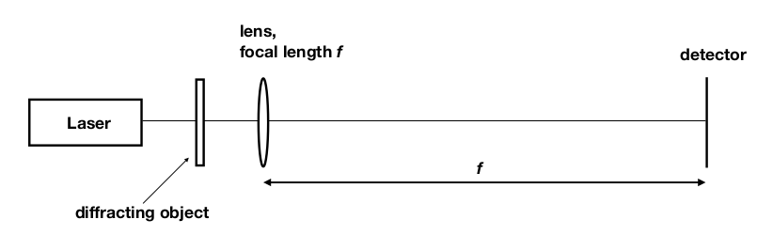

Figure 4: Basic arrangement of apparatus for measuring the characteristics of diffraction patterns. Slit(s) are placed close to laser output, and the detector is at the focal plane of the lens.

Source: Mangles et. al, 2021, “Year 1 Laboratory Manual: Diffraction Experiment”, Imperial College

A photodiode was used as the detector in this case, to measure the intensity of the diffraction pattern. This was then connected to a multimeter to collect voltage readings. Positions where the voltage was found to be at a local minimum corresponds to the position of minima - the photodiode voltage ∝ light intensity on diode. Both the slit and photodiode are attached to a precision translation stage, upon which the photodiode can be moved to measure diffraction pattern intensities at varying positions from the lens. The translation slide has a total range of 25m, whilst the stage has a range of approximately 1m.

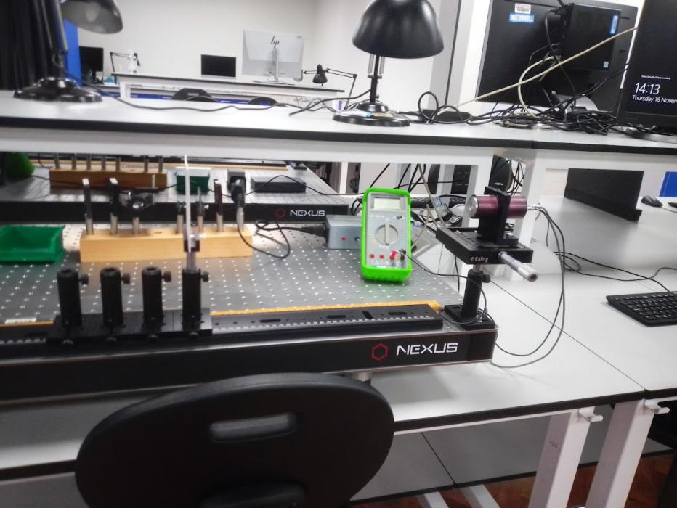

Figure 5: An photograph depicting the experimental set-up for the practicals. The CMOS camera unit could be substituted for the photodiode-multimeter unit.

An appropriate lens was selected from the three lenses with different *f* provided to give an optimally-sized diffraction pattern so that the positions of the zeros could be measured using the diode and translation slide. Uncertainty was calculated by ascertaining the range of displacement values over which the local minima of voltage (and therefore, intensity) occurred over. Then, the double slit slide replaced the single slit one, and the experiment was repeated for the double slit interference pattern.

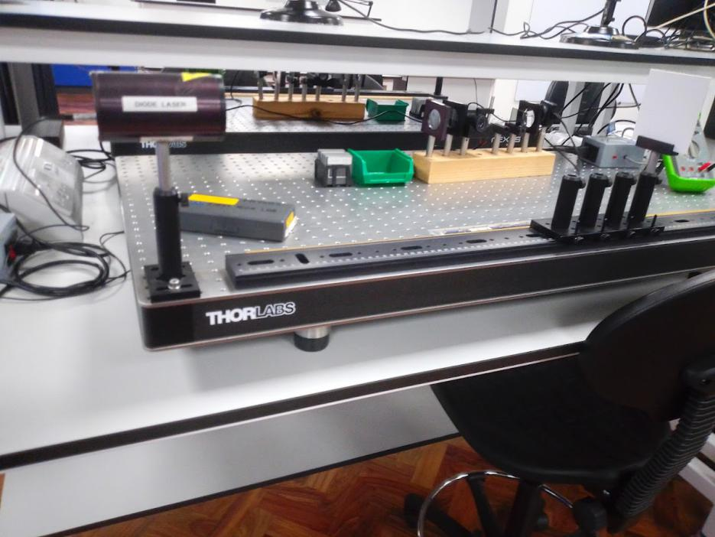

Figure 6: A view of the other end of the experimental set-up described in Fig. 5.

In the second experiment, rather than using the positions of minima to determine the physical dimensions of the slits, which assumes that our theoretical models provide an accurate description of the situation, digital images of the patterns, which were then processed, where utilised instead, to compare with our theoretical models.

The correct lens was selected to fit the diffraction pattern onto the CMOS detector, and the distance of the camera was adjusted so that it was the correct distance from the lens. Using the ThorCam™ application on Microsoft Windows™, we subsequently obtained an unsaturated image of the pattern, ensuring that exposure time was set short enough for this. The Horizontal profile plot was used to adjust the exposure time so that the peak of the central maxima was not cut off the chart (resulting in what can be seen in Figure 8). These images were saved in the lab, and then imported into ImageJ, it was rotated such that its axis was aligned with the gridlines. The rectangle tool was then used in conjunction with the Plot Profile command in order to obtain numerical values of the horizontal profile as a .CSV file, which was loaded into Python.

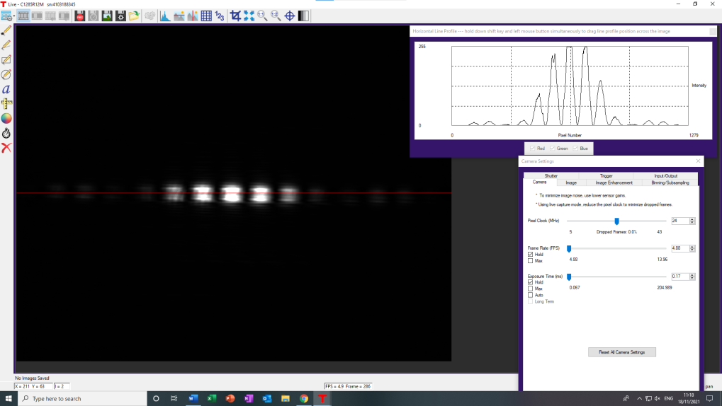

Figure 7: Using the horizontal plot profile tool for an image in ThorCam with low exposure time.

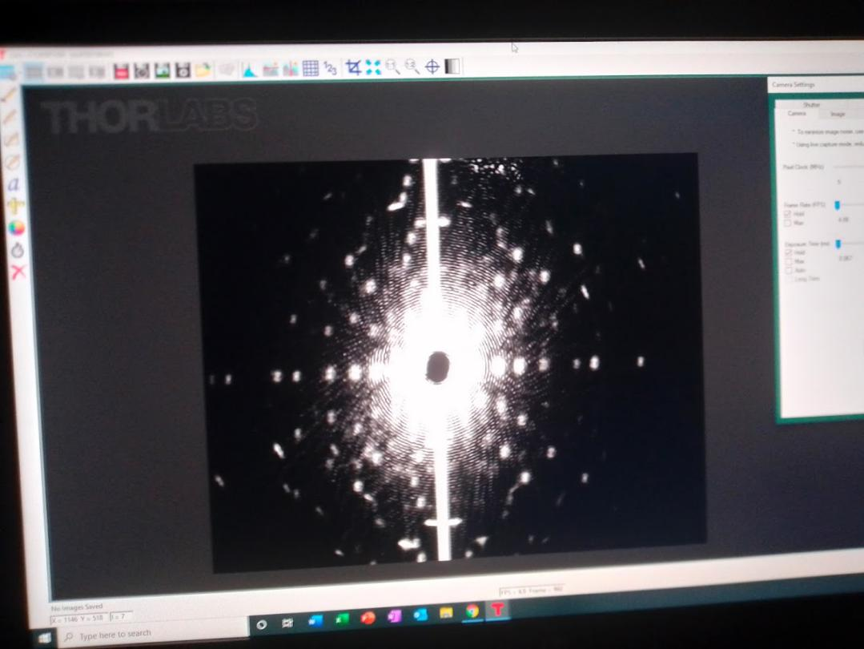

Figure 8: An image in ThorCam where the exposure time has been set too high.

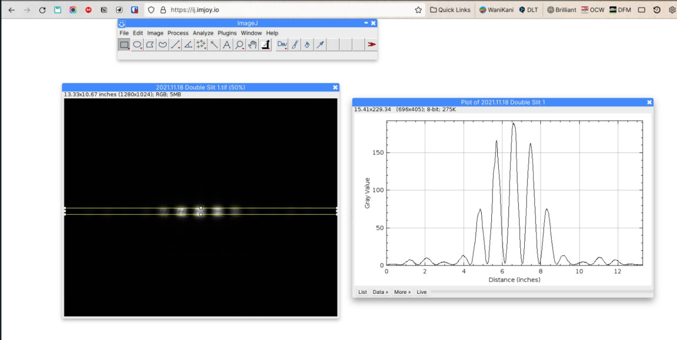

Figure 9: Image Processing of the double slit interference pattern in ImageJ

**Preliminary Data**

**Experiment A: Using diffraction to measure the physical dimensions of objects**

**670 ± 1 nm**

|  |  |  |  |  |  |  |  |
| --- | --- | --- | --- | --- | --- | --- | --- |
| **Experimental Data - Single Slit** | | | | |  |  |  |
| **n** | **Start Position / mm** | **End Position / mm** | **Median Position / mm** | **n** | **Distance from Centre / mm** | **Lower Bound / mm** | **Upper Bound / mm** |
| 3 | 22.81 | 21.75 | 22.28 | 3 | 10.86 | 0.53 | 0.53 |
| 2 | 19.94 | 18.65 | 19.30 | 2 | 7.88 | 0.65 | 0.65 |
| 1 | 15.53 | 15.26 | 15.40 | 1 | 3.98 | 0.14 | 0.14 |
| 0 | 11.42 | 11.43 | 11.42 | 0 | 0.00 | 0.01 | 0.01 |
| -1 | 8.16 | 8.06 | 8.11 | -1 | -3.31 | 0.05 | 0.05 |
| -2 | 5.09 | 4.73 | 4.91 | -2 | -6.51 | 0.18 | 0.18 |
| -3 | 1.86 | 0.86 | 1.36 | -3 | -10.06 | 0.50 | 0.50 |

|  |  |  |  |  |  |  |  |
| --- | --- | --- | --- | --- | --- | --- | --- |
| **Experimental Data - Double Slit** | | | | |  |  |  |
| **n** | **Start Position / mm** | **End Position / mm** | **Median Position / mm** | **n** | **Distance from Centre / mm** | **Lower Bound / mm** | **Upper Bound / mm** |
| 8 | 21.31 | 21.31 | 21.31 | 8 | 10.18 | 0.01 | 0.01 |
| 6 | 19.12 | 19.12 | 19.12 | 6 | 7.99 | 0.01 | 0.01 |
| 4 | 16.83 | 16.83 | 16.83 | 4 | 5.70 | 0.01 | 0.01 |
| 2 | 14.61 | 14.61 | 14.61 | 2 | 3.48 | 0.01 | 0.01 |
| 1 | *11.71* | *11.71* | *11.71* | 1 | 0.58 | 0.01 | 0.01 |
| 0 | 11.13 | 11.13 | 11.13 | 0 | 0.00 | 0.01 | 0.01 |
| -1 | *10.60* | *10.60* | *10.60* | -1 | -0.53 | 0.01 | 0.01 |
| -2 | 9.47 | 9.47 | 9.47 | -2 | -1.66 | 0.01 | 0.01 |
| -4 | 7.30 | 7.20 | 7.25 | -4 | -3.83 | 0.05 | 0.05 |
| -6 | 4.98 | 4.98 | 4.98 | -6 | -6.15 | 0.01 | 0.01 |
| -8 | 2.89 | 2.89 | 2.89 | -8 | -8.24 | 0.01 | 0.01 |

**Experiment B: Investigating the Diffraction Pattern**

The following rudimentary plots were obtained from ThorCam™ 's horizontal line profile tool. This was used to adjust the exposure time and other parameters manually to obtain the optimal image.

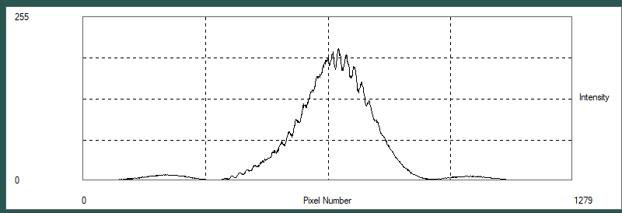

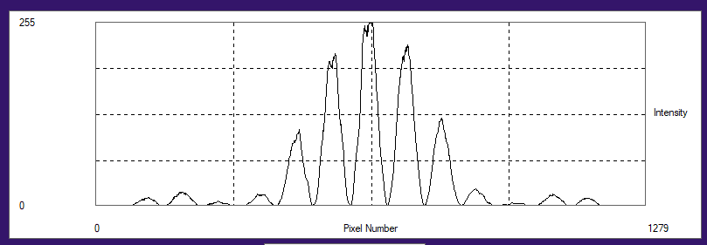

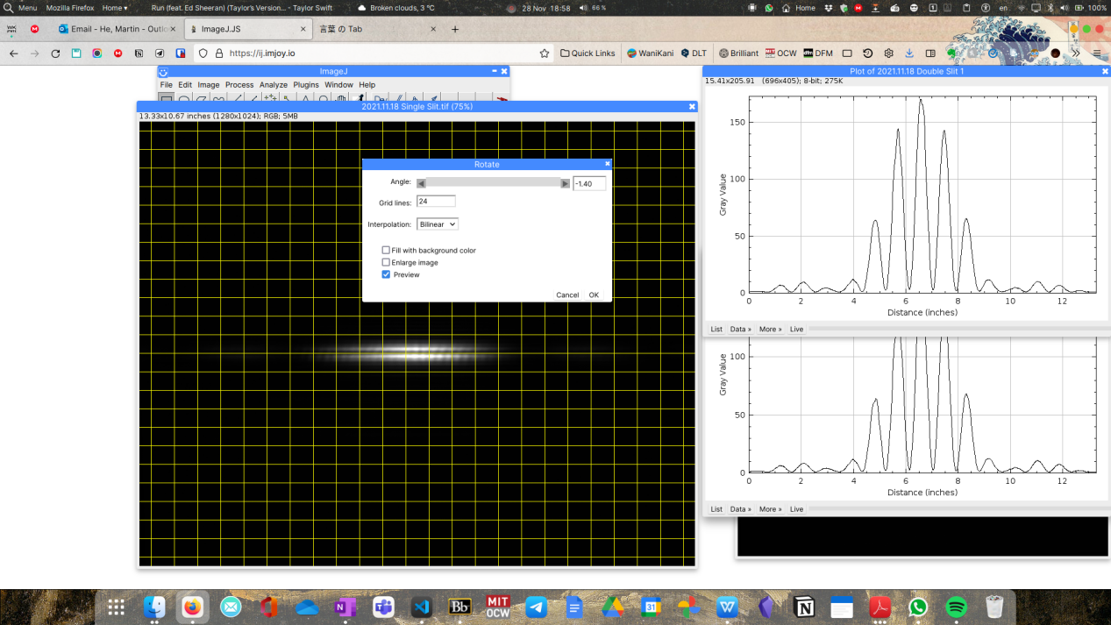

**Data Analysis/Sources of Uncertainty**

**Experiment A: Using diffraction to measure the physical dimensions of objects**

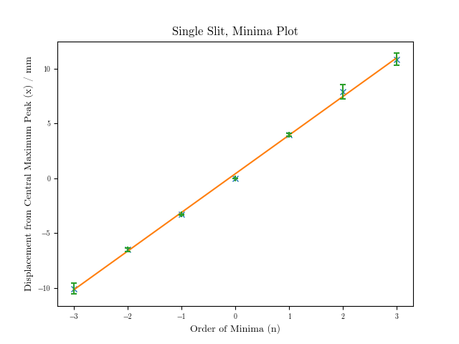

Single Slit Diffraction: R2 = 0.9988

gradient: 3.53+/-0.06

y-intercept: 0.41+/-0.11

a= 9.49e-05 +/- 6.48e-05 m

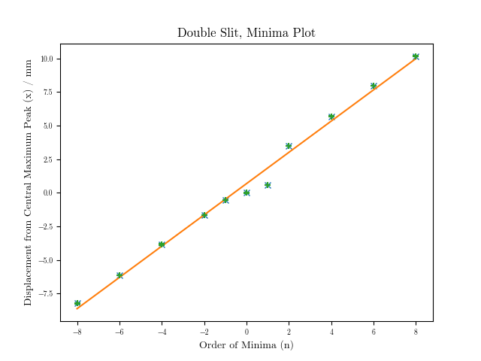

Double Slit Diffraction: R2 = 0.9917

gradient: 1.16+/-0.04

y-intercept: 0.68+/-0.17

d= 2.88e-04 +/- 4.31e-05 m

**Experiment B: Investigating the Diffraction Pattern**

**Single Slit Diffraction**

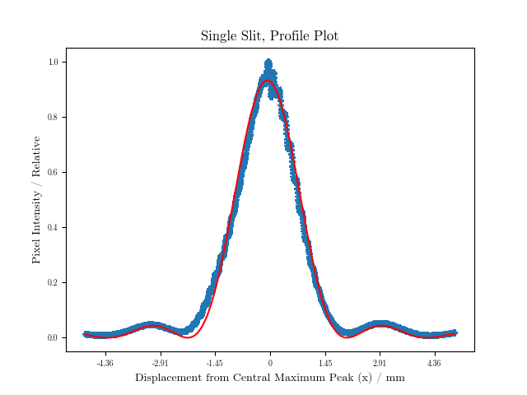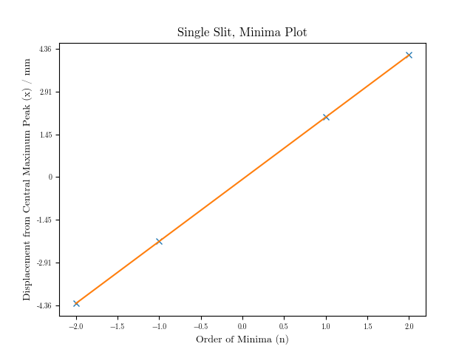

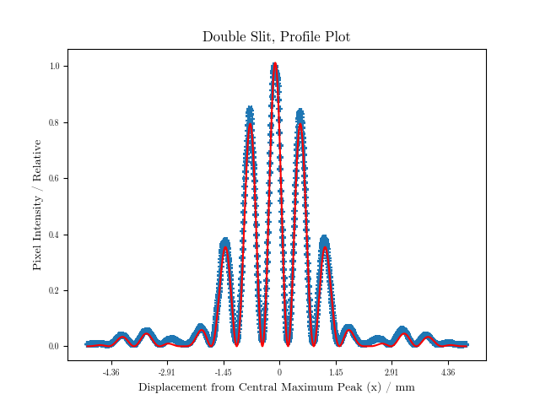

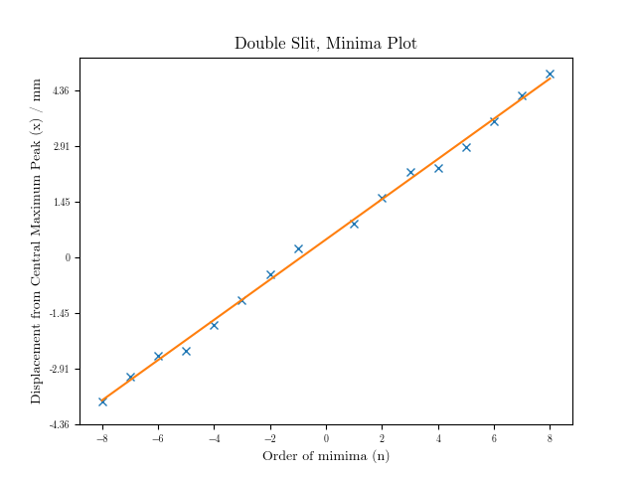

In order to take into account for the scaling between the CMOS camera and the pixels, as well as the rendering on ImageJ, scale factors were applied to the single and double slit experimental data to obtain the following results:

**Single Slit Diffraction:**

a = ( 0.0001151+/-0.0000023 ) m

**Double Slit Diffraction:**

d = ( 0.000464+/-0.000012 ) m

**Summary**

To conclude, when comparing the two sets of data:

A: a= 9.49e-05 +/- 6.48e-05 m

B: a= 1.151e-04+/- 2.3e-06 m

A: d= 2.88e-04 +/- 4.31e-05 m

B: d= 4.64e-04 +/- 1.2e-05 m

We find that they are both within the same order of magnitude with each other, which although they are each off by roughly 2e-05 and 2e-04 respectively. As a result, this demonstrates that the measurements made manually are a good estimation of what we ascertained via. the CMOS camera.